1)Create A Project

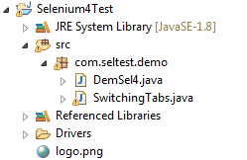

2)open/search Git Perspective in search

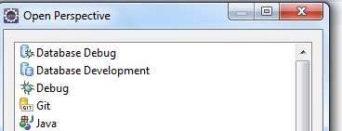

3)Create a Local Repository(xyz)

4)Select Your project from Eclipse>Team>ShareProject

5)Configure your Git(Local ) Repository Path>Finish

6)

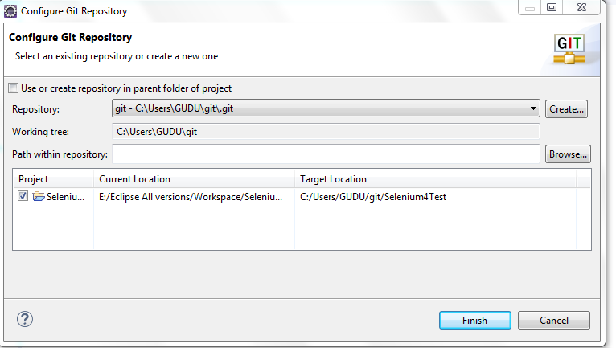

7)Select Your Project in Eclipse>Add To Index>Commit(With Message)

8)

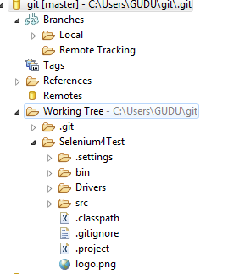

Create a Repository in github account Push your Changes to Master Branch

URL:: <https://github.com/preetishIbankG99/Selenium4.git>

Project>Team>Remote>Push>give source def(Master) and Dest Ref>Add spec>Finish

Step 1 Completed

Step2

Add Collaborators/Manage Access>Add People>Send Invite Link with Git master URL>As a tester I can see it in My github login account The project Shared By Team Lead

Suppose you are new Joinee in a XYZ Company so You can clone project From Github Url shared By your TL…

Enter To Eclipse>open git perspective>Clone a Git Repository(Given By your Company)

As a Tester give your Github account Username and password>Select master Branch>It wil create

A new Git New Repository(Local)>Right Click On Project Exlporer>Existing Git Repository

Suppose You are making a new Test Case Or Changes Which is not part of your local repository

So Create a new Class>Create a new Branch(Feature) ##Dont Try to push Your Code In Master Branch

Directly Create a new Feature Branch>>>(Now You are In Feature)Open Your Git Repository(Local)>>>Under Branches>Right Click>Switch To new Branch>After Branch Creation>Go to Eclipse Project>Right Click >Team>Add to Index>Team>Commit>A File Will Be pushed To Your Feature Branch>Right Click on File Which is pushed in feature Branch>Push Branch

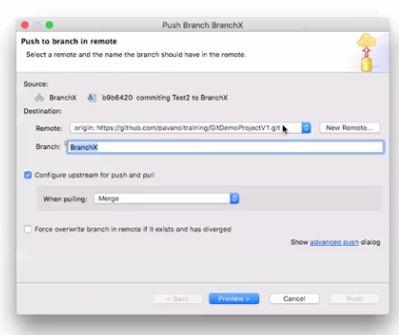

Click on Preview>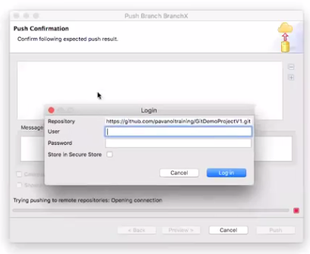

Give your Github account username and Password(QA TESTER)>Login>Click On Push

Push Changes to Remote rep(Github)from new feature Branch

CLICK ON NEW PULL REQUEST>>ADD REVIEWRS(ADD LEAD or Any Other Senior Most Software)